1-After running the program, select your desired algorithm and press the "Start" button

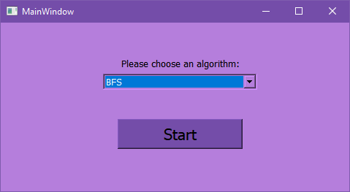

2-The maze will appear, you can use left click to select the start point and right click to select the end point on the generated maze

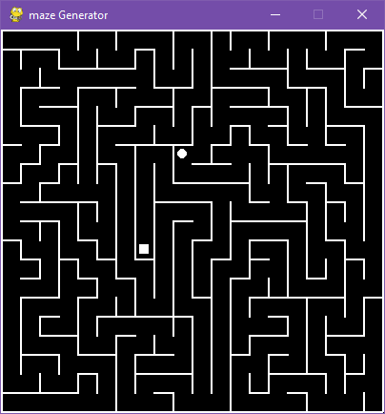

3-Press enter to find the path using the selected algorithm or space to generate a different maze

-You can use different points again after finding the generated path (refer to step 2)

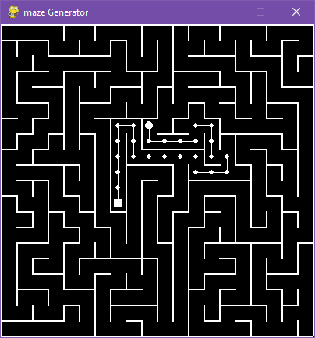

4-Press the 'X' button in the top right to exit the maze and a window will appear showing the path, cost, time, and expanded nodes of the chosen algorithm with the selected points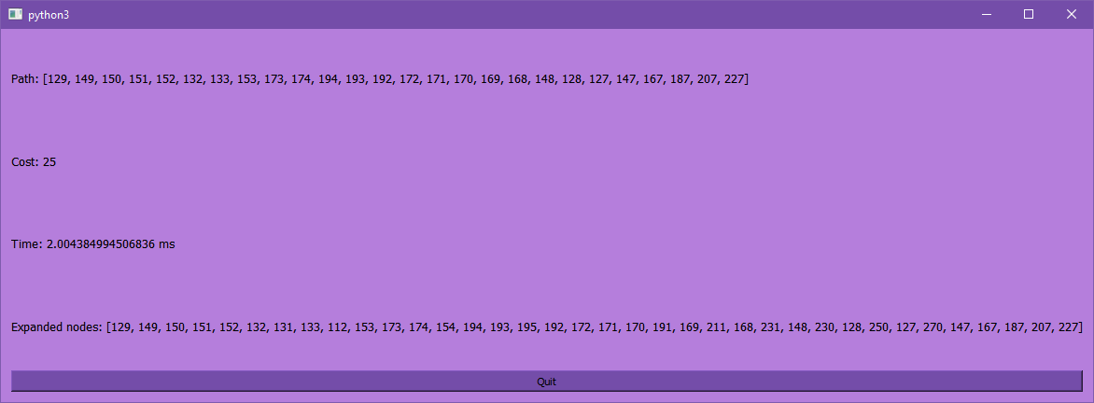

-For ease of use; the path, cost, time, and expanded nodes are printed on the terminal each time you hit enter without exiting the generated maze.

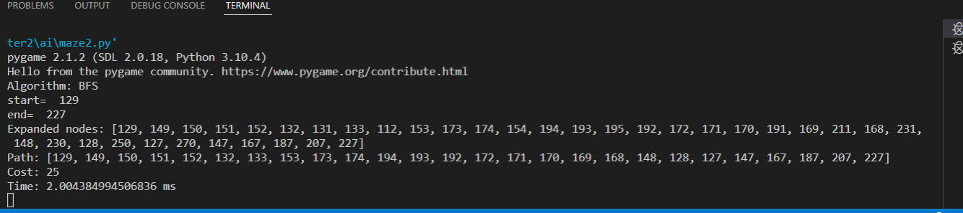

5-Finally, press the "Quit" button to end the program